
A Journey of Spectacular Scenery, Fabulous Food, and Fun Friendships along The Armstrong Trail!
This year’s ride is in honor of and in memory of
Jim Holden, Trail Blazer and founder of the
Erie To Pittsburgh Trail Alliance.
Fifth Annual
SPONSORS
REGISTRATION
Fruit and water at the starting and mid points
Picnic lunch at Nautical Mile Campground in Templeton - (vegetarian and kid friendly options will be available)
Fire pit with marshmallows and live music!
$25.00 - Regular registration by May 13th
(Register & pay by April 15th and receive a trail visor)
$30.00 - Late registration/walk-in after May 13th
$15.00 - Children ages 10-18
$5.00 - Children under 9

FOOD/FUN
DONATION
RIDE / WALK
SATURDAY, MAY 21, 2016 9 AM – 3 PM

Hosted by The Armstrong Rails to Trails Association and The Allegheny Valley Land Trust
All Proceeds to Benefit Development of The Trail

Event Starts and Ends at the
Nautical Mile Campground
530 Stone Ave, Templeton, PA
Rain or Shine

Ride or walk north or south of the campground on the Armstrong Trail and return for lunch, entertainment and a campfire. Suggested routes and maps will be available.
Ride distances can be anywhere between 1-58 miles

Platinum Level:
Gold Level:
Silver Level:
M& M Lime Company, Inc. NexTier Bank,
Snyder Charitable Foundation
CWM Environmental, Inc. ,
Shellhammer Atwood and Associates

Farmer's National Bank , W. D. Mohney & Associates
Rosebud Mining Co. , Kay & Steve Owen, Bradigan’s, Inc.

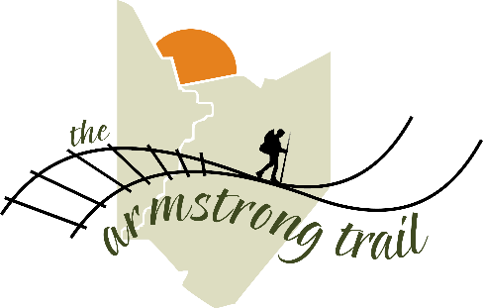
Name:___________________________________________________________________________
Address:_________________________________________________________________________
Email:_________________________________________________Phone:____________________
Is this your first Eat, Play, Ride?________

Send completed registration form with check made payable to ARTA to:
Toni Henry, 901 Purdum St., East Brady, PA 16028.
Contact Toni with any questions at toni.henry51@gmail.com or 412-759-9152

