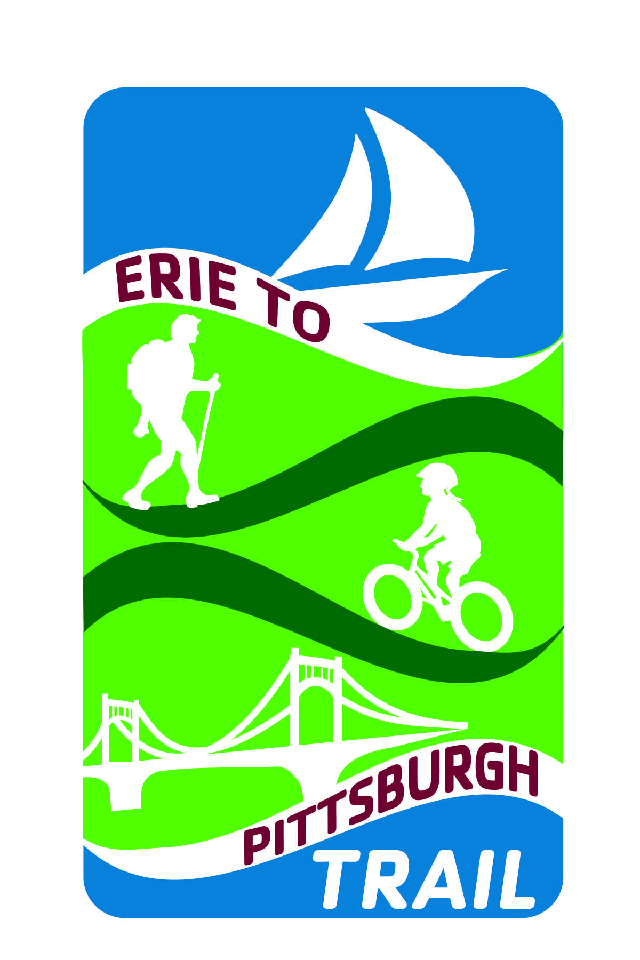
Erie to Pittsburgh Trail Alliance

EPT Logo Use Policy

The Erie to Pittsburgh Trail Alliance (EPTA) is a collaborative organization of 16 individual trail groups and municipalities currently working on completing and promoting multi-use recreational trail projects in western Pennsylvania. Together these groups are focusing creating one unified non-motorized route that will connect the shores of Lake Erie Bayfront to the Point in Pittsburgh. The Erie to Pittsburgh Trail will also have connections to a network of trail systems promoting the region as a destination.

The EPTA encourages its member organizations to use the logo and will grant permission to do so without charge, provided they follow the guidelines in Section I below. All other individuals, corporations, and organizations must follow the provisions in Section II for any use of the logo and a fee for use will be assessed.

Failure to follow the provisions in Section II or use of the logo without prior express written permission of the EPTA and payment of required fees may result in civil liability, including penalties, legal fees and costs. Any manufacturing, selling, or creation of a product, or photographs or prints in any other manner, any engraving or impression in the likeness of this logo, or any colorable imitation thereof, without written authorization from the EPTA is subject to the penalty.

Please contact the EPTA Board with questions, for more information or to request use of the logo:

(North) 217 Elm Street
Oil City, PA 16301
814-677-3152
dfrawley@oilregion.org
(South) 33 Terminal Way
Suite 333B
Pittsburgh, PA 15219
412-488-0212
thomas@friendsoftheriverfront.org

All Users – General provisions:
- The EPT logo is a registered trademark of the EPTA and is only used by permission.
- Do not alter the graphics in any way. Please maintain the specific colors, proportions, style, font, etc.
- Pantone Matching System colors are: PMS 307 Blue; PMS 368 Light Green; PMS 349 Dark Green; PMS 506 Brown
- Font is: Cachet

Section I: EPTA member organization use:
The use of the EPT logo by member organizations is encouraged. Show trail unification by using these standard graphics in your marketing materials as well as on the trail itself in addition to the individual trail (group) name and logo. In order to maximize the effectiveness of this logo and to maintain and preserve its integrity, EPTA member organizations must follow these Standards.
- You may not alter the EPT logo in any manner when you use it.
- You may not combine the logo with any other graphic element or use it as an element in any other graphic design.
- Use of the EPT logo must be truthful and not misleading. You may not use the EPT logo to imply any relationship with, endorsement or sponsorship by the Erie to Pittsburgh Trail Alliance or any of its members that is not true.

The EPTA reserves the right to develop publications and products that feature the EPT logo. The member organizations may use the logo for publications and products, however, the EPTA requires that, prior to publication or product development:
- Member organizations submit in writing or by e-mail the proposed design for and receive written approval from the EPTA.
- This permission will be valid for a period of two years, after which it must be renewed if continued use is desired.
- Oral requests will not be approved.
- Approval must be obtained in writing prior to publication.
The EPTA will make every effort to supply said approval promptly and will not unreasonably delay delivery of said approval. It is asked that member organizations coordinate the development of products that are based solely on the EPT logo with the EPTA and other member organizations.

Section II: Non-member, Individual and/or for profit use:
Any individual, organization or corporation must obtain the prior written consent of the Erie to Pittsburgh Trail Alliance in order to use the Erie to Pittsburgh Trail logo for any purpose, including but not limited to use on printed material, products or web sites. Written requests should be forwarded, along with a detailed description of the intended purpose and use, to Erie to Pittsburgh Trail Alliance or send by e-mail to:
(North) 217 Elm Street
Oil City, PA 16301
814-677-3152
dfrawley@oilregion.org
(South) 33 Terminal Way
Suite 333B
Pittsburgh, PA 15219
412-488-0212
thomas@friendsoftheriverfront.org

Oral requests will not be approved nor responded to. The EPTA will respond to written requests as soon as possible. After you have received the written consent, you agree to the following terms and conditions:
  - You may not alter the Erie to Pittsburgh Trail logo in any manner when you use it.
  - You may not combine the logo with any other graphic element or use it as an element in any other graphic design.
  - Use of the EPT logo must be truthful and not misleading. You may not use the logo to imply any relationship with, endorsement or sponsorship by the Erie to Pittsburgh Trail Alliance or any of its members that is not true.
  - You may not use the EPT logo in connection with any misleading or disparaging statements about the Erie to Pittsburgh Trail or the Erie to Pittsburgh Trail Alliance or its products, or statements that otherwise reflect poorly on the Erie to Pittsburgh Trail Alliance or any of its member organizations.
  - Your use of the logo acknowledges the Erie to Pittsburgh Trail Alliance's proprietary rights to this logo, and you agree not to adopt, use, register, or attempt to register anywhere in the world any logo or trademark confusingly or deceptively similar to the Erie to Pittsburgh Trail logo.
  - You will acquire no rights to the EPT logo through or by way of the Alliance's permission for a specific use of the logo and shall take no action inconsistent with the Erie to Pittsburgh Trail Alliance's interest in the logo.
  - Permission for a specific use does not imply permission for any other or subsequent use. If you intend to use the logo for a use other than that for which you have obtained permission, you must obtain specific written permission from the Alliance for that new or subsequent use.
  - The Erie to Pittsburgh Trail Alliance reserves the right to take action to the fullest extent of the law against any individual, organization, or corporation for any misuse or unfair, misleading, diluting or infringing use of any Erie to Pittsburgh Trail logo or trademark.
  - Unless required to use a more specific legend by any additional agreement you may have from the Erie to Pittsburgh Trail Alliance, you agree to use the following legend on the page where the EPT logo appears or where there are other legal notices on your publication or product: "Erie to Pittsburgh Trail logo is a registered trademark of the Erie to Pittsburgh Trail Alliance and is used by its permission."
  - Failure to follow the provisions of this Section II or use of the logo without prior express written permission of the ATA may result in civil liability, including penalties, legal fees and costs.

The Erie to Pittsburgh Trail Alliance will assess a fee for any commercial use of the logo based on the commercial value of the product or publication being developed. The EPTA will assess a nominal fee for non-commercial uses and reserves the right to waive this fee. The EPTA will consult with its member organizations regarding fee for use assessed to commercial or non-commercial organizations that are located in member organization's geographic area. Waiver of a fee for any commercial or non-commercial use does not imply waiver of such fee for any subsequent use.

The Erie to Pittsburgh Trail Alliance reserves the right, at any time and without cause, to modify or suspend these policies and to withdraw any permission granted to any party under and pursuant to these policies to use of any Erie to Pittsburgh Trail logo.

Adopted and approved by EPTA Board action _____________________
Attachments: EPT Logo use request form
Erie to Pittsburgh Trail Alliance

EPT Logo Use Request Form

Requested by: __________________________________________________
___EPTA Member ___Non-member ___For Profit Request

Logo to be used on/in:
________________________________________________________________________________________________________________________________________________________________________________________________________________________________________________
* Please attach a copy or picture of item to be produced

Number of items to be produced: _______
How will the item be disseminated: (internet, hard copy, web, email, selling of product, etc.)

________________________________________________________________________________________________________________________________________________________________________________________________________________________________________________________________________________________________________________________________

Contact Person: _____________________________________________________
Phone: ___________________________________
Email: ____________________________________
Mailing Address:____________________________
____________________________
____________________________

Affiliated Trail Group: _________________________________________________

Authorized signature of requesting organization: ______________________________ Date: ___________

EPTA specifications or restrictions: __________________________________________________________ ______________________________________________________________________________________________________________________________________________________________________________

Fee for use: $____________ Expiration date of this authorization: _______________________

Erie to Pittsburgh Trail Alliance authorization: _________________________________ Date: ___________

